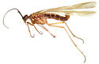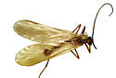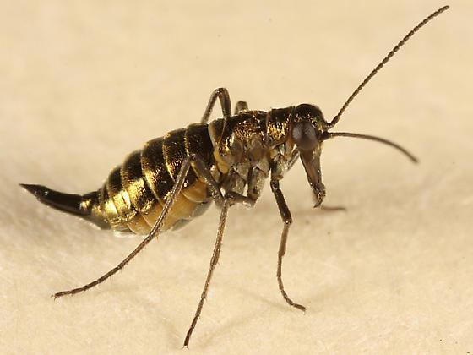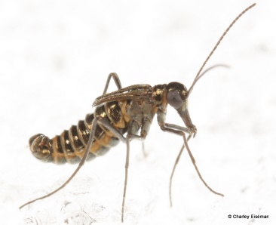

**Panorpidae – common scorpionflies**

**Boreidae – snow scorpionflies**

7. Families in Mecoptera – scorpionflies